HUMA Analysis

<https://journals.lww.com/jtrauma/fulltext/2023/08000/evaluation_of_vascular_repair_by_tissue_engineered.11.aspx>

* HUMA released pre-clin study looking at ATEV/ HAV vs ePTFE in porcine model
* N=36 pigs, 4 treatment groups
  + receiving either the HAV or a PTFE graft following a hind limb ischemia period of either 0 or 6 hours
  + 3cm by 6mm
  + In right eliac artery
  + Not immune suppressed for 1st mth
  + Eval: graft patency, hind limb function, biochem markers/ histology
  + Hind limb function and tissue damage biomarkers improved?
* Multiple typos in paper
* In methods say PTFE not ePTFE
* Paper below says infection rates wont be different btwn synth and nat
* Embolisms?
* 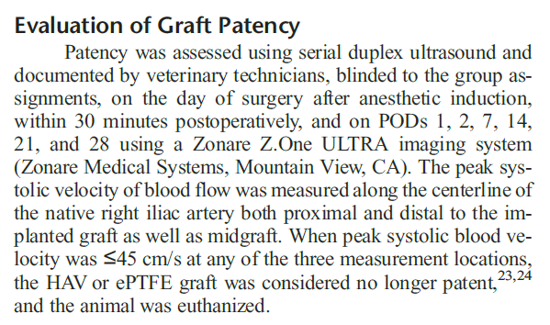

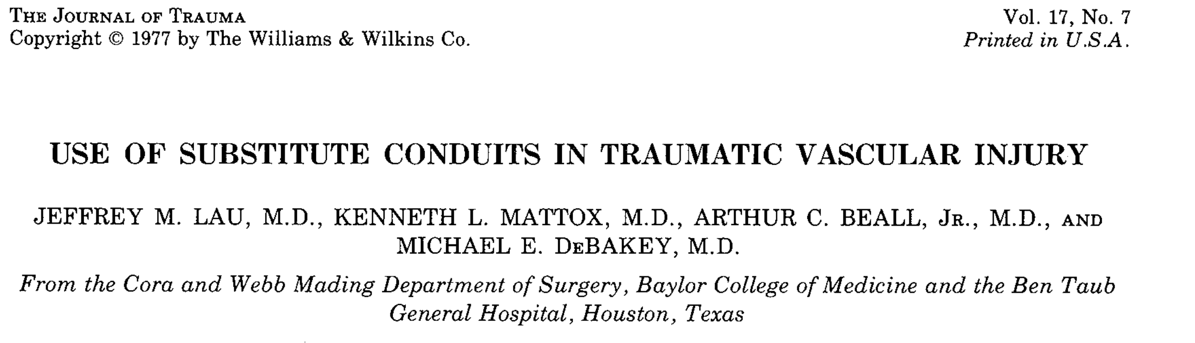

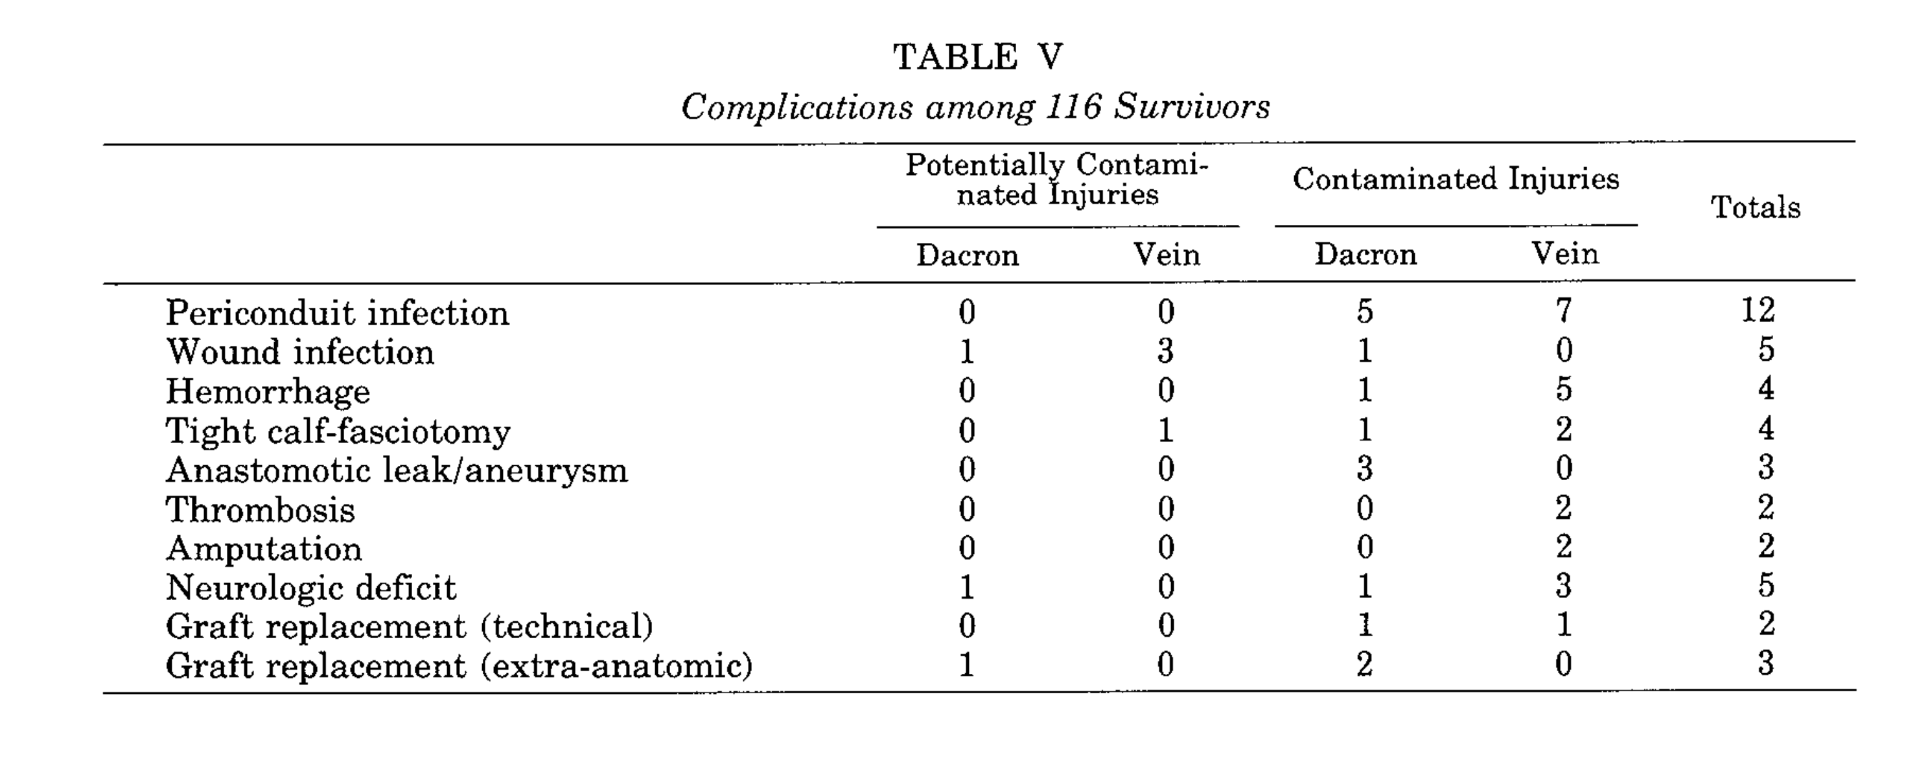

Rates of infection don’t differ much between synthetic and saphenous veins

https://www.ncbi.nlm.nih.gov/pmc/articles/PMC7768973/

* Vein grafts constituted 82% of the repairs and had a similar estimated patency of 93% compared with 81% for all other repairs.
* Proportion of scripts that are vein vs PTFE/ other?
* Upper extremity arterial cohort: Vein grafts constituted 90% of the repairs and had a patency of 97% compared with 33% for all other repairs (p<0.001; only five repairs were in this group).
* Lower extremity arterial patency: Lower extremity estimated arterial repair patency was 91% with median follow-up of 20 months

chrome-extension://efaidnbmnnnibpcajpcglclefindmkaj/https://www.fda.gov/media/158495/download

PTFE graft BLA

HC Wainright call 09/10/2024

* Have treated 600 pts? Data??
* 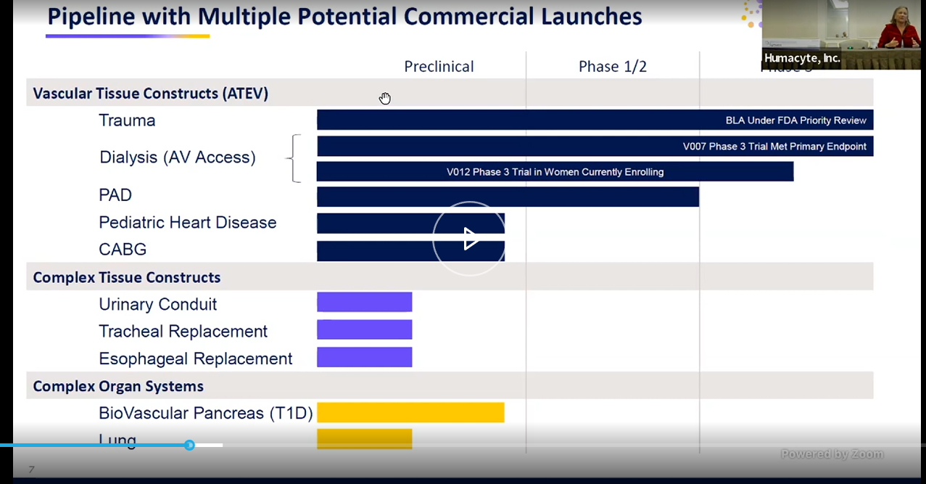
* DOD supported ph3 trial in BLA submission
* 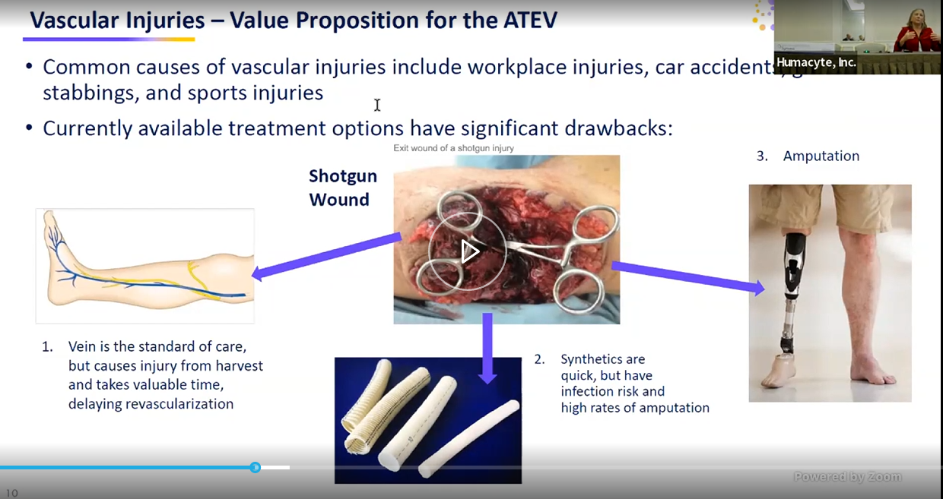
* She says infection rate is “quite high” on grafts vs their approach
* 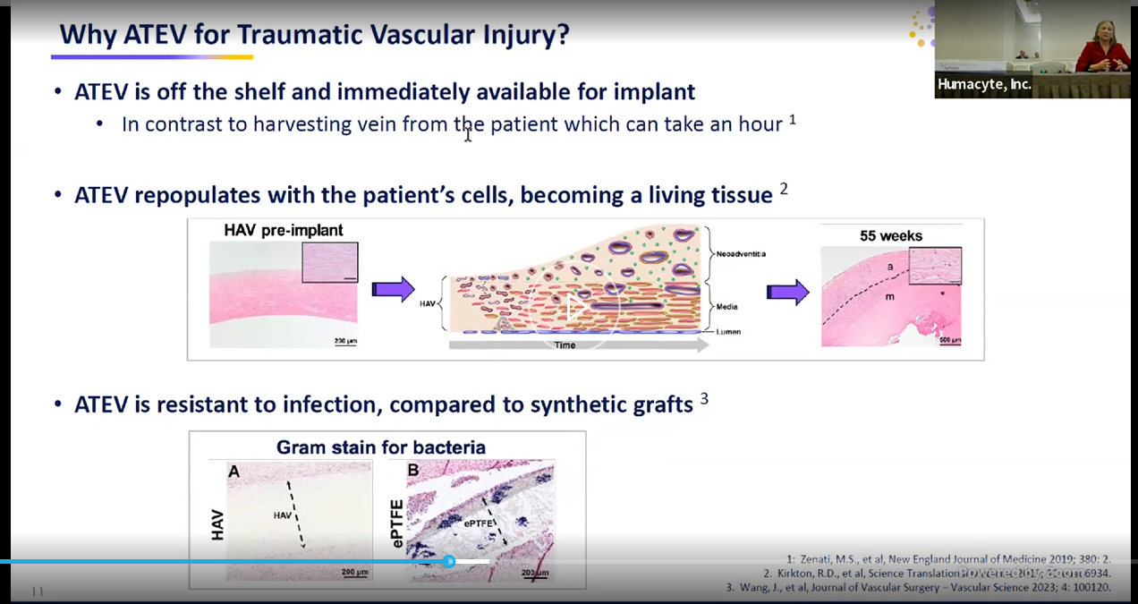
* 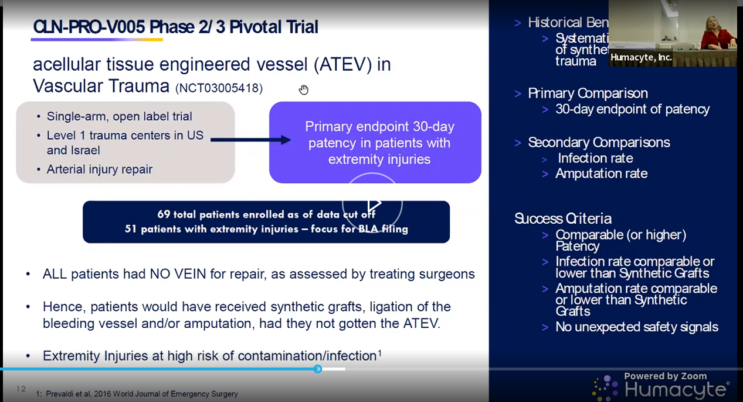
* Will follow pts for 3yrs on this study
* 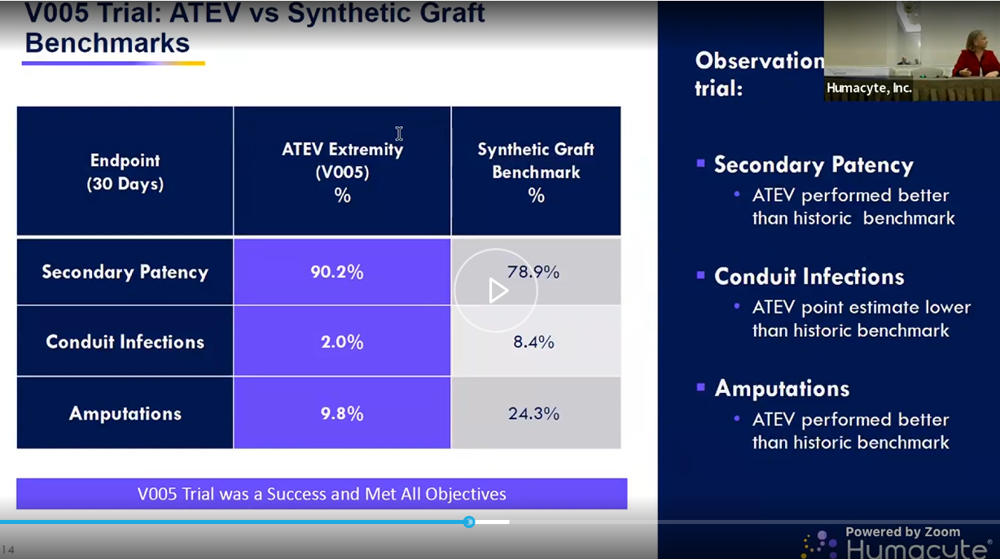
* 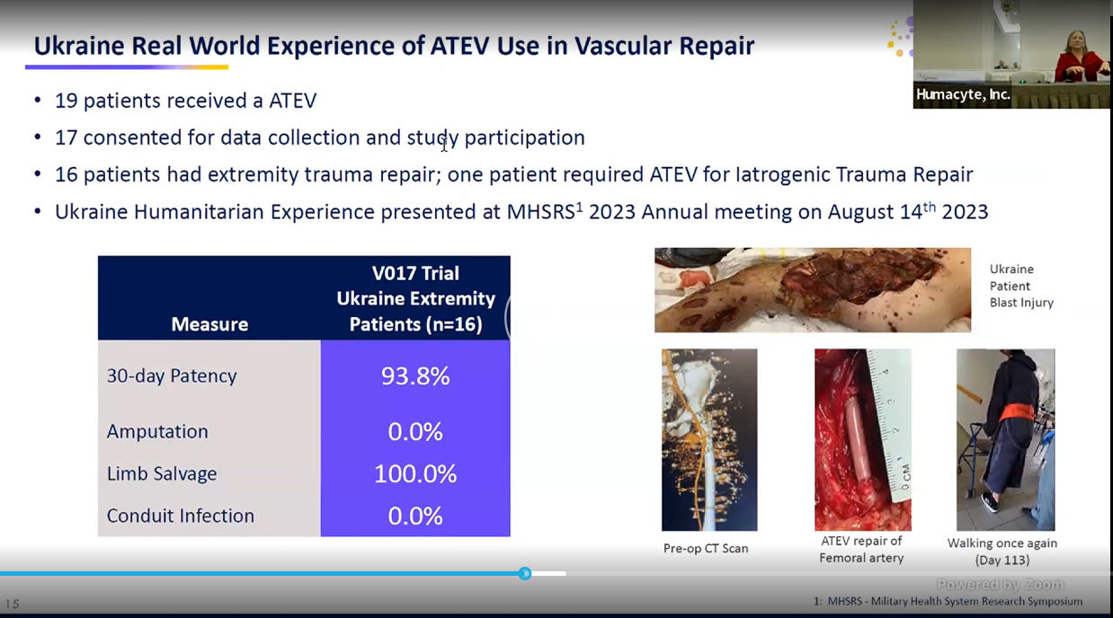
* Docs trained over zoom?
* 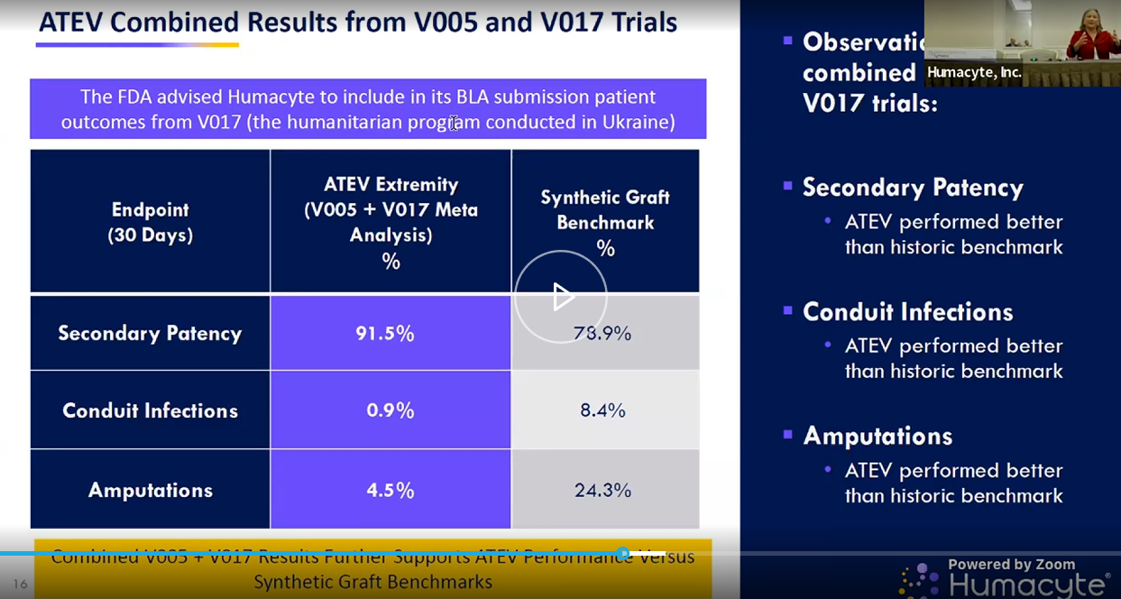
* 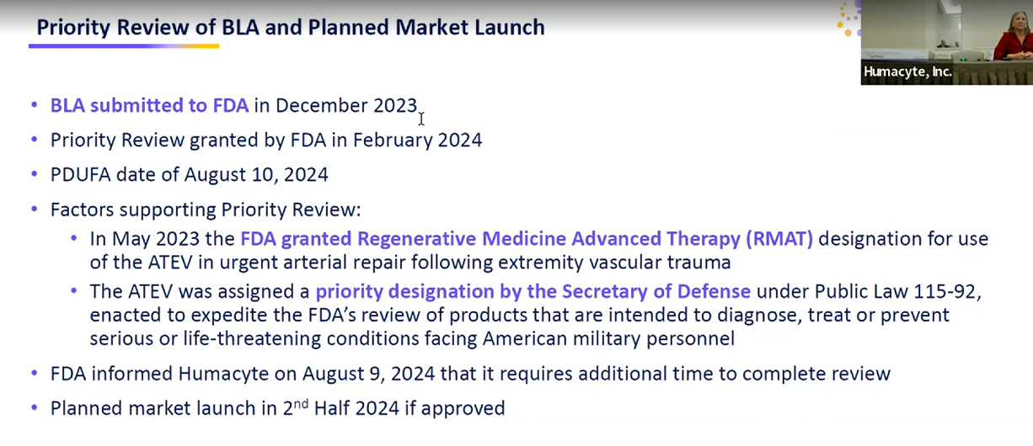
* “we’ve completed inspections and labelling talks and post approval commitments w FDA”
* “we do not have a new PDUFA data, expect to hear in coming weeks and months”
* 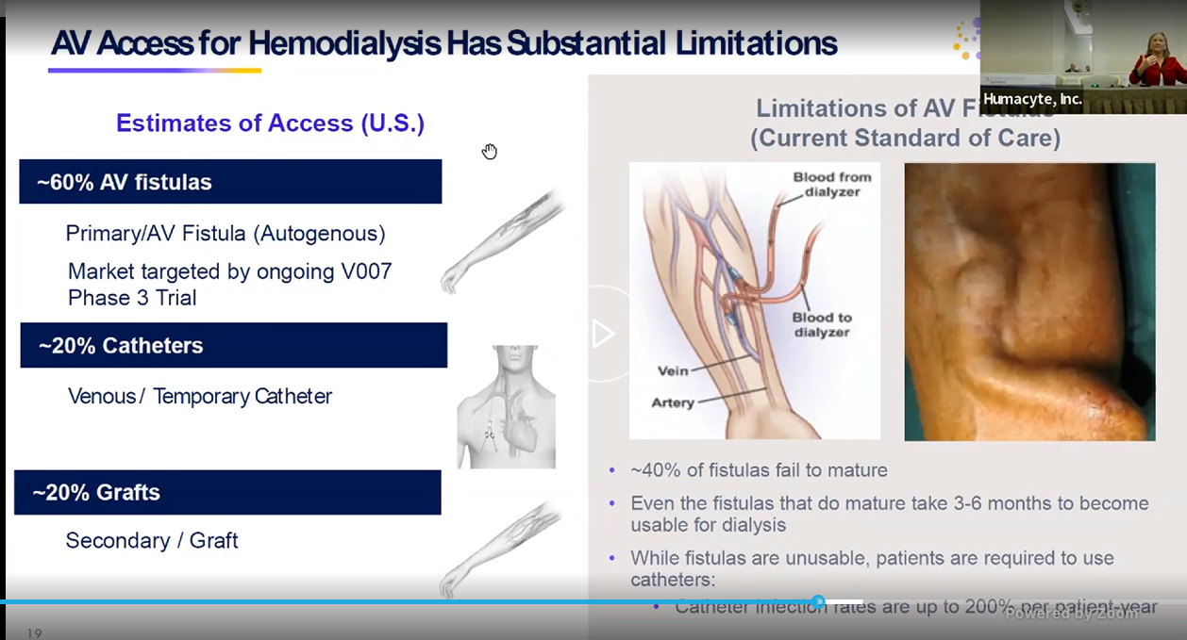
* 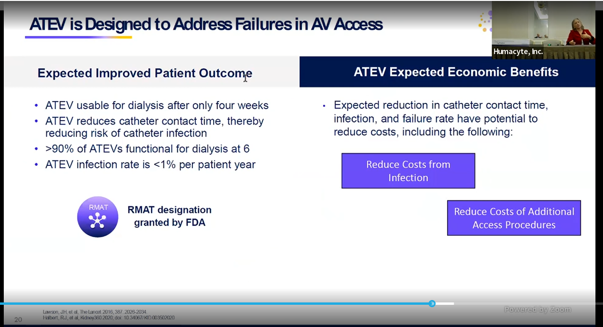
* 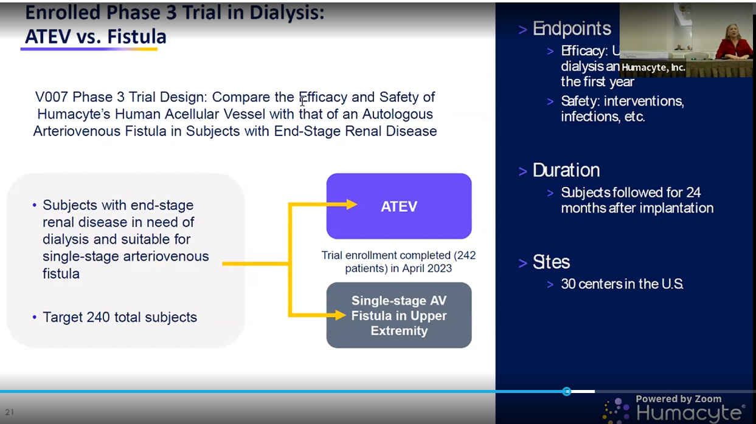
* 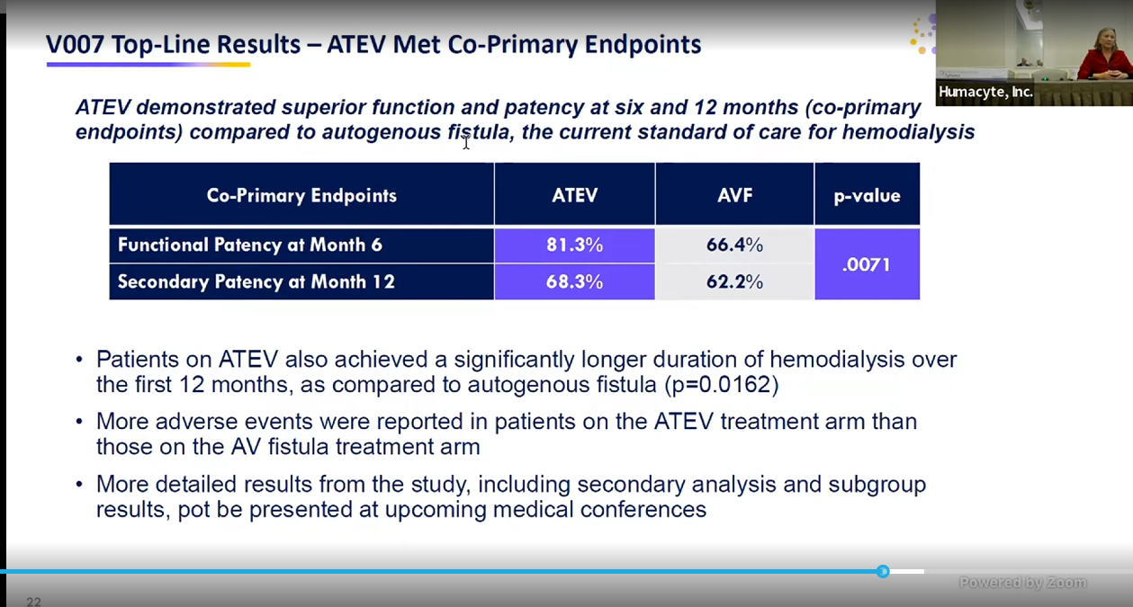
* Also have sub groups they are keen to share those with us soon! In several weeks at KOL webinar
* This study is done already
* 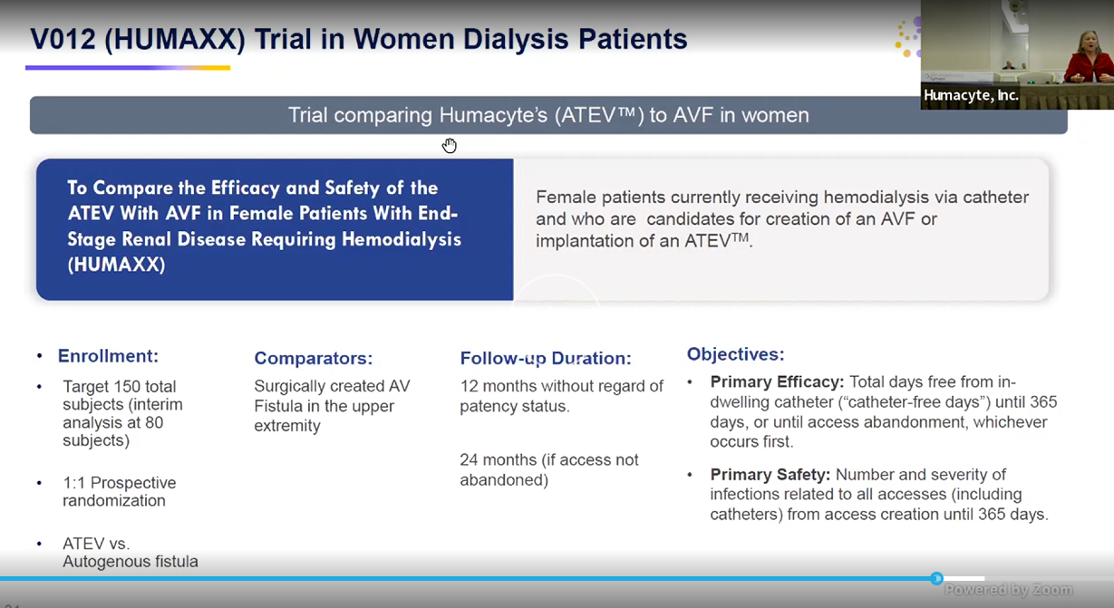
* 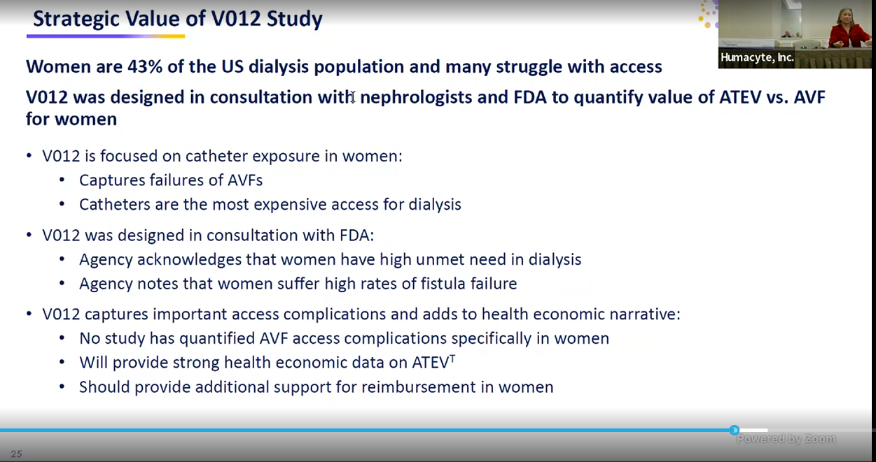
* 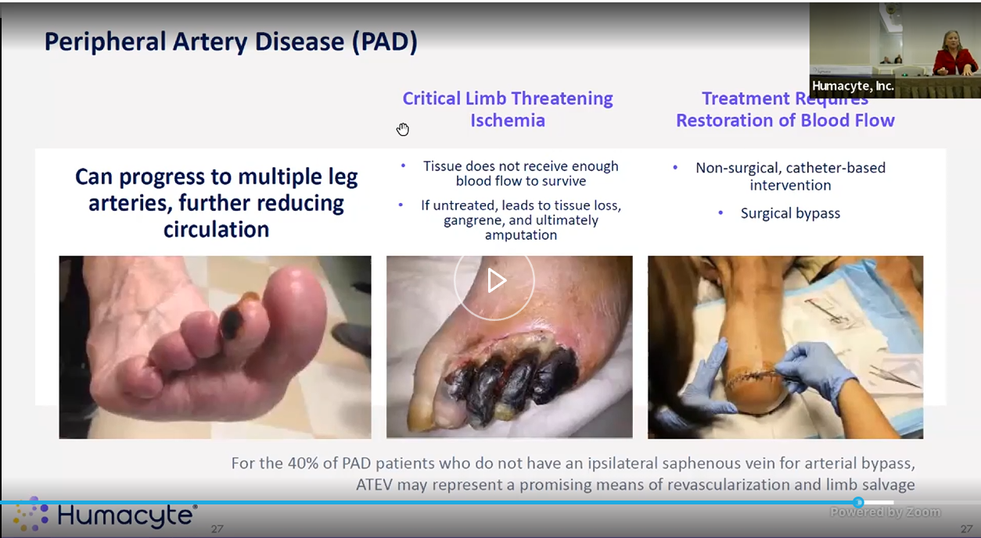
* Skipped thru the following
* 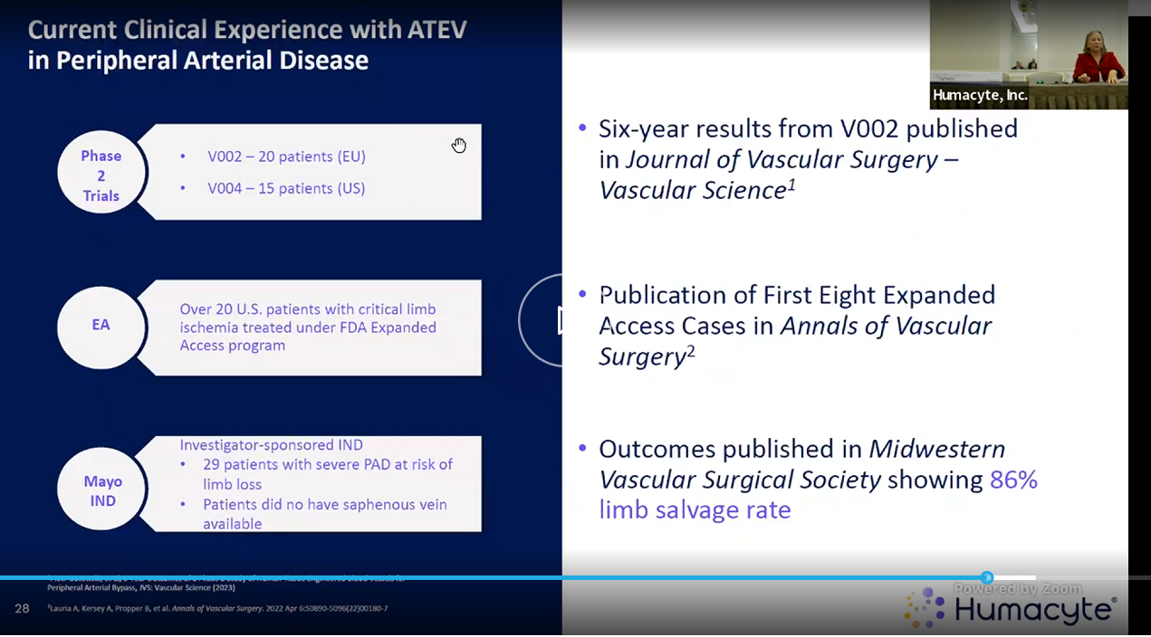
* 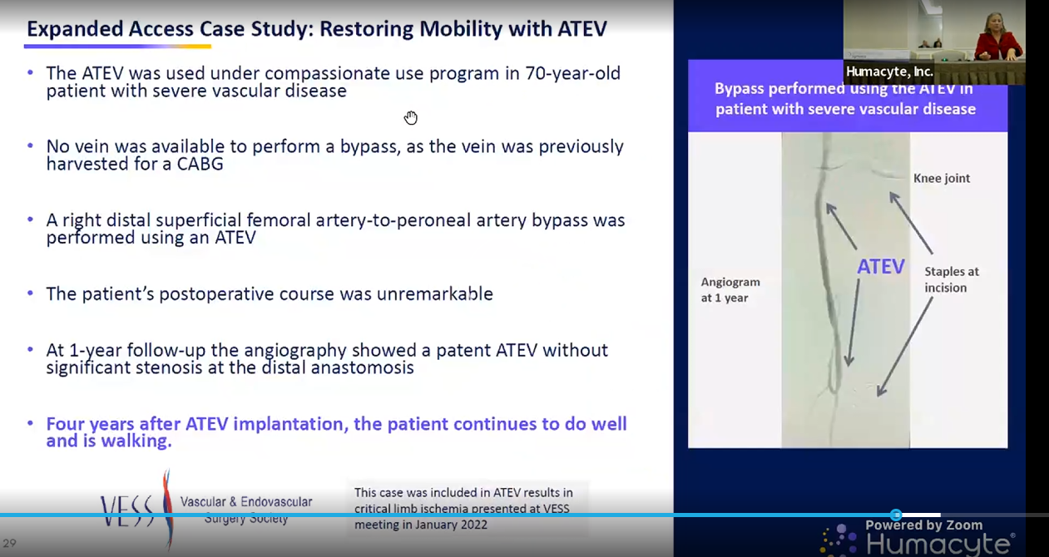
* 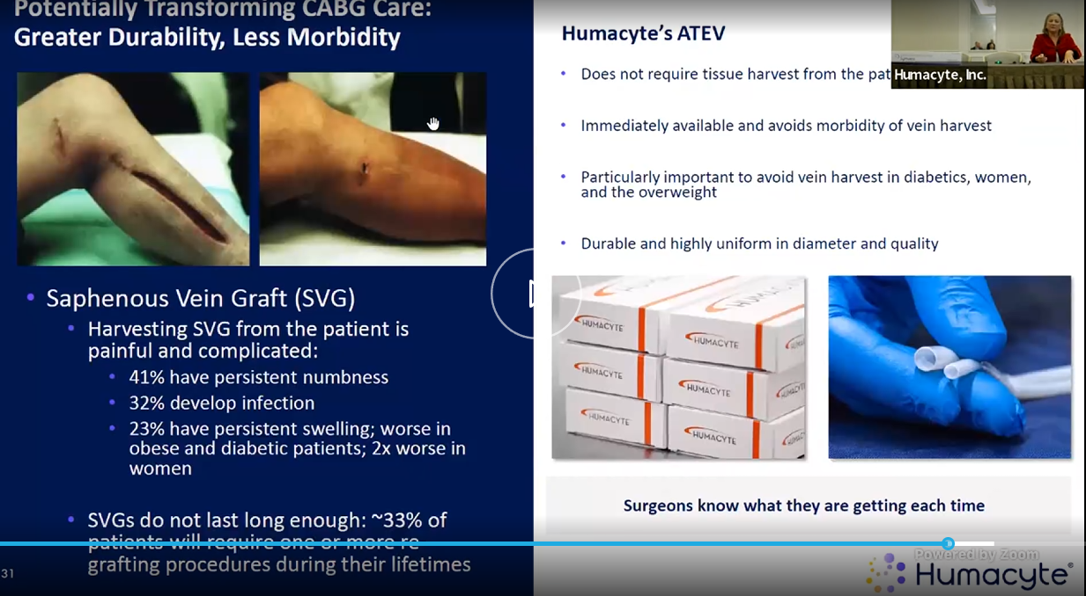
* 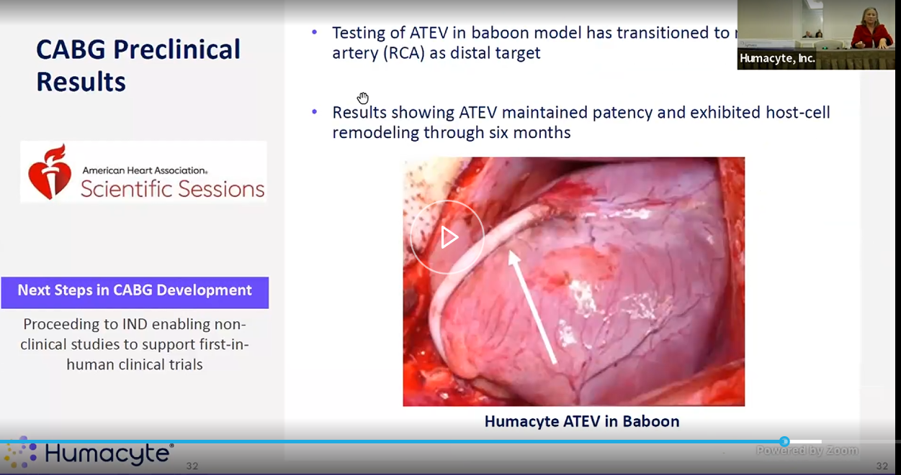
* 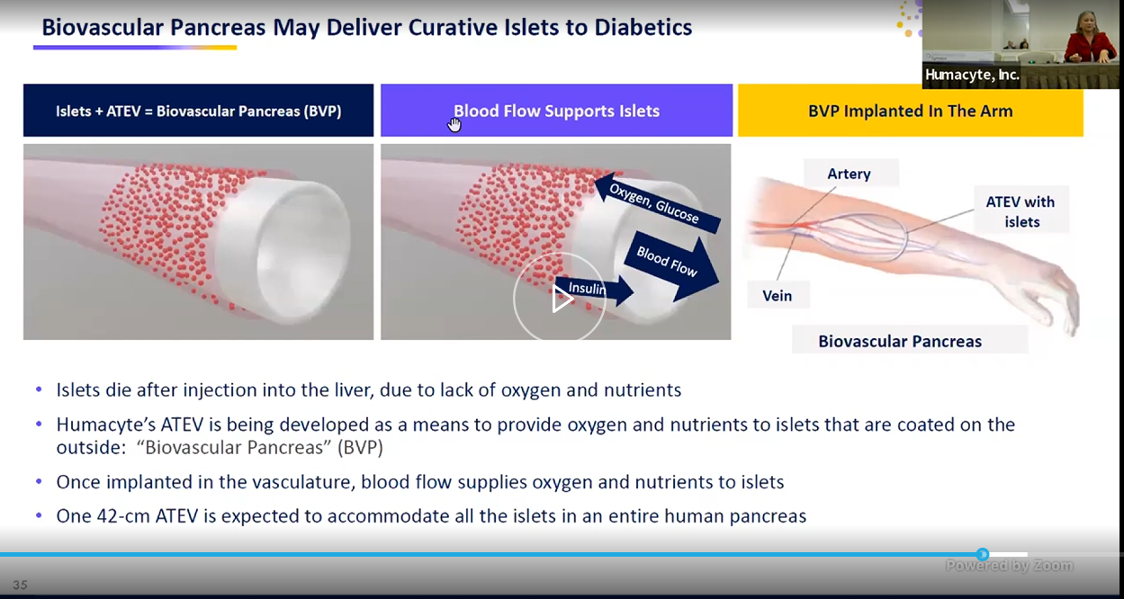
* 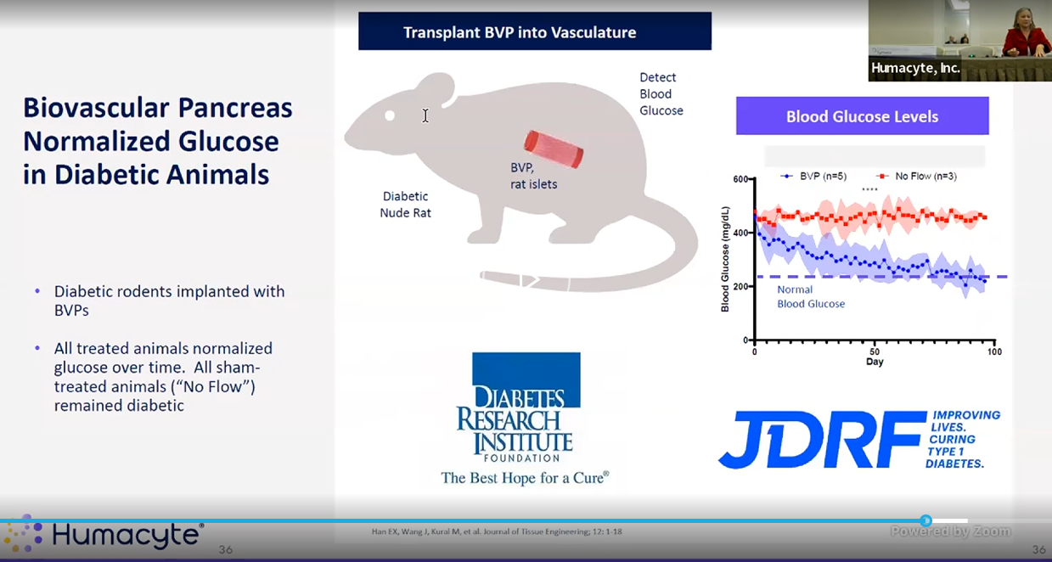
* 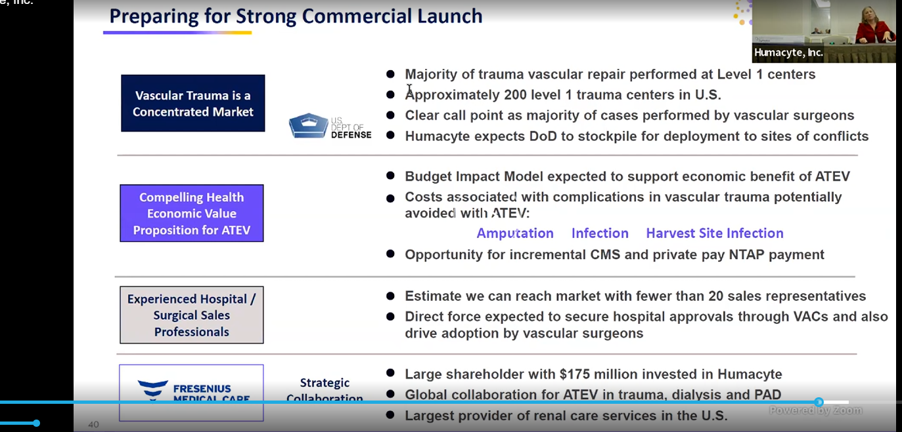
* 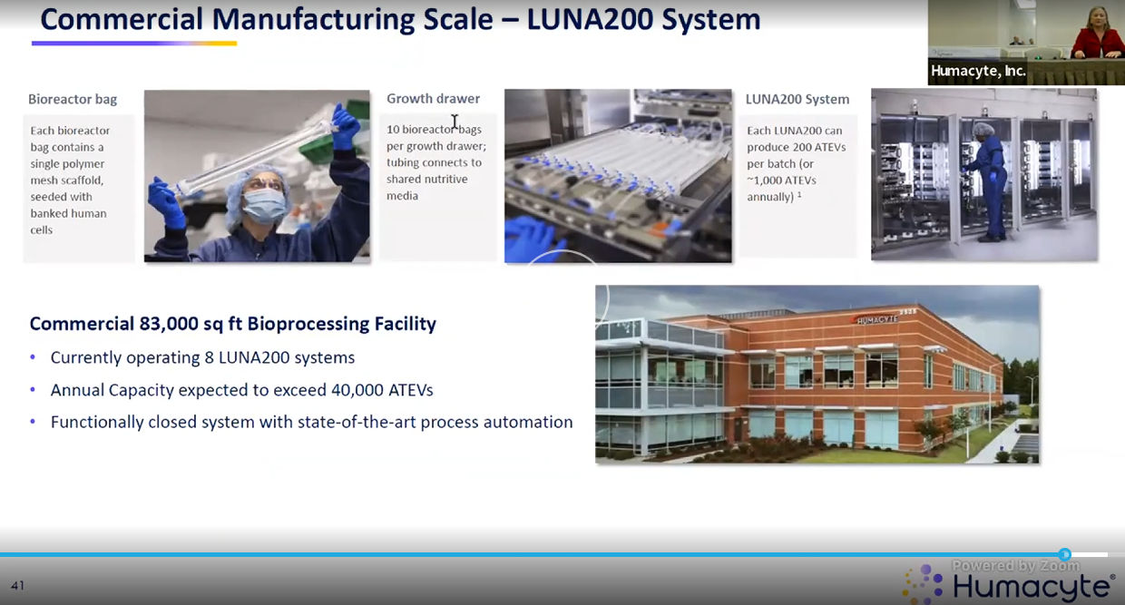
* 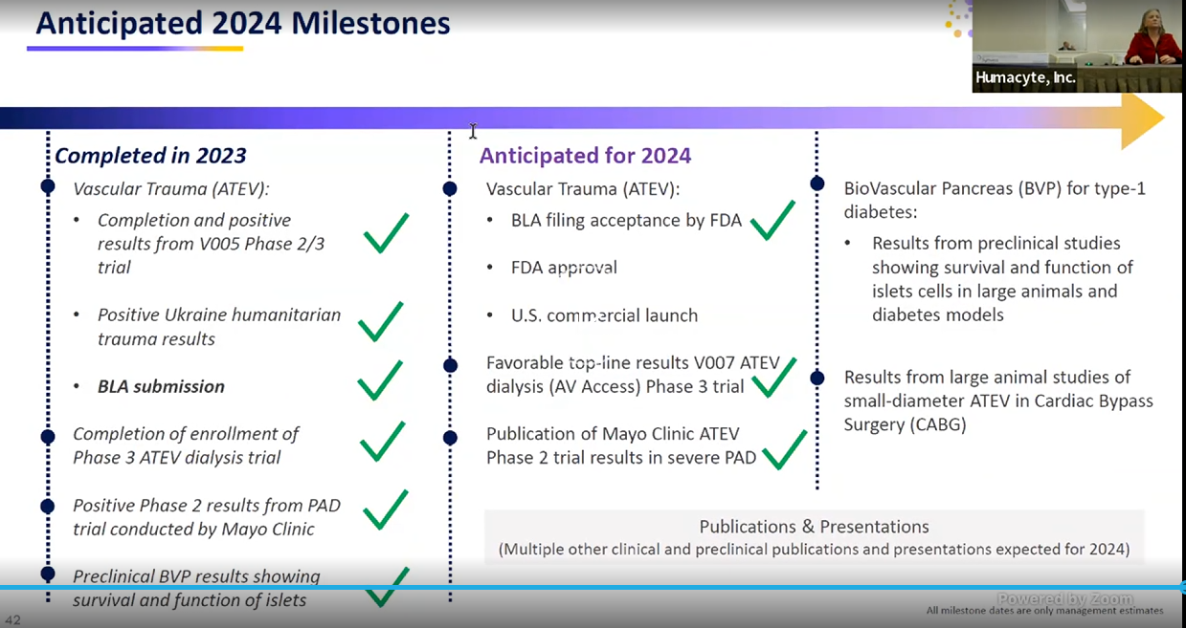
* 20% of facility is actually occupied rn. Rest can be expanded.